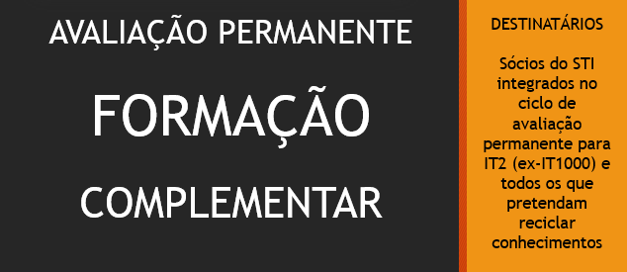

FICHA DE INSCRIÇÃO

NOME _______________________________________________________________________
N.º DE SÓCIO ______________ E-mail ______________________________________________
CATEGORIA PROFISSIONAL _______________________________________________________
LOCAL DE TRABALHO _______________________________ Tel. _________________________

LOCAL ONDE PRETENDE FAZER A FORMAÇÃO

Aveiro Beja Braga Castelo Branco Guarda Leiria Lisboa Viana do Castelo Viseu

QUESTÕES QUE GOSTARIA DE VER ABORDADAS PELOS FORMADORES

MÓDULO I – IRS
__________________________________________________________________________________________________________________________________________________________________________________________________________________________________________________________________
MÓDULO II – LGT, CPPT e RCPITA
__________________________________________________________________________________________________________________________________________________________________________________________________________________________________________________________________
MÓDULOS III e IV – IRC e SNC
__________________________________________________________________________________________________________________________________________________________________________________________________________________________________________________________________
__________________________________________________________________________________________________________________________________________________________________________________________________________________________________________________________________

ENVIAR PARA FORMACAO@STIMPOSTOS.PT ATÉ 10 DE SETEMBRO DE 2018

